**Information Visualisation Assignment-05**

**Name: Shiva Kumar Peddapuram**

**KSU REG.NO: 811235874 (**[**speddapu@kent.edu**](mailto:speddapu@kent.edu)**)**

**Steps:**

Initially I have logged into by pressing google and then given Kent state credentials.

Then I have created a deployment named as “IVHW05”

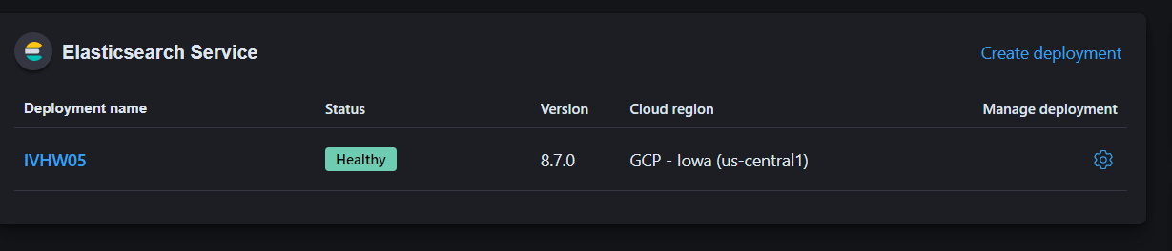

Next, I have entered into the deployment by clicking on it:

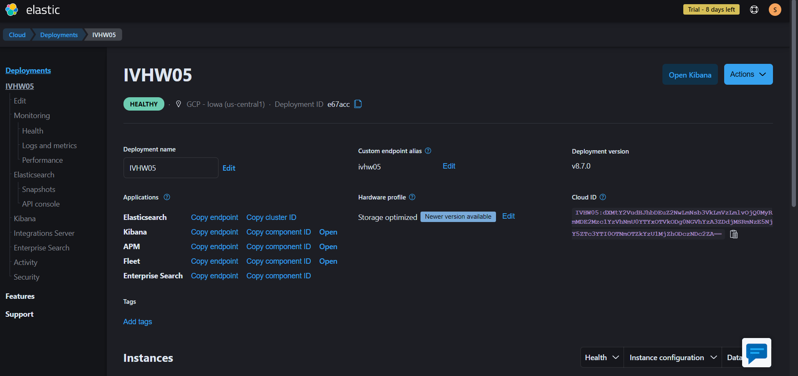

The dashboard page looks like this:

Next I clocked add integration button then sample data and the more sample datasets:

I have created visualisation and then saved:

Next, I have cloned the dataset:

Next I have saved the dashboard as per the requirements mentioned in the assignment file.

Here is the permalink to my Assignment:

<https://ivhw05.kb.us-central1.gcp.cloud.es.io:9243/app/dashboards#/view/470eeec0-d7ca-11ed-9ecc-bbc64fae7f95?_g=(refreshInterval%3A(pause%3A!f%2Cvalue%3A900000)%2Ctime%3A(from%3Anow-7d%2Cto%3Anow))>

<https://ivhw05.kb.us-central1.gcp.cloud.es.io:9243/app/dashboards#/view/470eeec0-d7ca-11ed-9ecc-bbc64fae7f95?_g=(refreshInterval%3A(pause%3A!f%2Cvalue%3A900000)%2Ctime%3A(from%3Anow-7d%2Cto%3Anow))>

**Final Visualisation:**

Below is the link which is in short form and this is a snapshot link:

https://ivhw05.kb.us-central1.gcp.cloud.es.io:9243/app/r/s/jB0mD